Batch: B2 Roll No.: 16010122158

Experiment / assignment / tutorial No. 3

Grade: AA / AB / BB / BC / CC / CD /DD

Signature of the Staff In-charge with date

Title: Implementation of Basic operations on stack for the assigned application using Array and Linked List- Create, Insert, Delete, Peek.

Objective: To implement Basic Operations on Stack i.e. Create, Push, Pop, Peek for the given application

Expected Outcome of Experiment:

CO | Outcome
1 | Explain the different data structures used in problem solving

Books/ Journals/ Websites referred:
- Fundamentals Of Data Structures In C – Ellis Horowitz, Satraj Sahni, Susan Anderson-Fred
- An Introduction to data structures with applications – Jean Paul Tremblay,
Paul G. Sorenson
- Data Structures A Pseudo Approach with C – Richard F. Gilberg & Behrouz A. Forouzan
- https://www.cprogramming.com/tutorial/computersciencetheory/stack.html
- https://www.geeksforgeeks.org/stack-data-structure-introduction-program/
- https://www.thecrazyprogrammer.com/2013/12/c-program-for-array-representation-of-stack-push-pop-display.html

Abstract:
(Define stack, enlist stack operations).

Stack is a linear data structure which follows LIFO (Last In First Out) order in which all the operations are performed.
Stack operations are as follows:
Push operation: Insertion of element into stack.
Pop operation: Deletion of element from stack.
Peek operation: Show element on top of stack.
Display operation: Show contents of stack.

List 5 Real Life applications:
- Converting infix to postfix expressions.
- Undo/Redo operation in word processors.
- Recursion
- Forward-backward surfing in browser.
- Backtracking

Stack ADT:
Stack contains elements of same data type arranged in sequential order.
All operations take place at a single end that is at the top of the stack.
Following operations can be performed:
push() – Insert an element at top of the stack, if stack is not full.
pop() – Remove and return element at top of stack, if stack is not empty.
peek() – Return element at top of stack without removing it, if stack is not empty.
size() – Return number of elements in the stack.
isEmpty() – Return True if stack is empty, False otherwise.
isFull() – Return True if stack isfull, False otherwise.

Algorithm for stack operations using array/Linked list :
Push operation:
- Check stack full condition
if (top == MAX - 1)
print stack is full/ stack overflow
- Else increase top value by 1
top = top + 1
- Input the value
- Assign item at top position
stack[top] = pushed_item
Pop operation:
- Check stack empty condition
if (top == -1)
- Else delete top position element
popped_item = stack[top]
- Decrease position of top
top = top - 1
- Print popped item
Display operation:
- Check stack empty condition
if (top == -1)
print underflow
- Else for element in stack, print element
for (i = top; i >= 0; i--)
print stack[i]
Peek operation:
- Check stack empty condition
if (top == -1)
print stack empty
- Else print element at current position

Implementation Details:
Enlist all the steps followed, and various options explored.
Implementation using arrays:
1) Initialize variable top which shows position of current element to -1
Declare array Stack of size mentioned in variable Size
Declare functions push(), pop(), peek(), display()
2) Function Push():
Declare variable x to store element to be pushed which is entered by user.
Check stack overflow condition, if all elements of array are filled i.e top == Size – 1, print Overflow
Else take user input for element to be pushed.
Increment top by 1, top = top + 1
Store pushed element at top of stack, Stack[Top] = x
3) Function Pop():
Check stack underflow condition, if top == -1, print Underflow
Else print element at top i.e at Stack[Top]
Decrement top by 1, top = top -1
4) Function Peek():
Check stack underflow condition, if top == -1, print Underflow
Else print element at top of stack i.e at Stack[Top]
5) Function Display():
Check stack underflow condition, if top == -1, print Underflow
Else declare i to keep a count of array elements and initialize it to have value of top.
for element in array, print element until counter i reaches 0.

Implementation using linked lists:
1) Define a structure Node having members element (integer) and prev (pointer to previous node).
element contains the value in the stack, prev contains the address to the previous node.
Declare a structure pointer *top initialized to value NULL.
2) Function Push():
Declare a structure pointer *newNode for holding address to current node.
Assign memory to the new node using malloc.
Store value of pushed element in element member of node.
If it is the first node, store NULL in prev
Else store address of previous node in prev (which was formerly stored in top)
Re-set top with address of newly formed node.
3) Function Pop():
Check for underflow condition, i.e if top == NULL, print Underflow
Else declare a structure pointer *temp and initialize it with value in top.
Declare an integer temp_element and store the element in element member of top.
Re set top with address of previous node
Free memory at address temp
Return temp_element i.e the popped element
4) Function Display():
Check for underflow condition, i.e if top == NULL, print Underflow
Else declare a structure pointer *temp and initialize it with value in top.
Top currently holds address of node in which latest element was pushed and it is assigned to temp.
While prev member of temp is not NULL
Print values which are pointed to by top till first element encountered.
Program source code:
Stack implementation using Arrays:
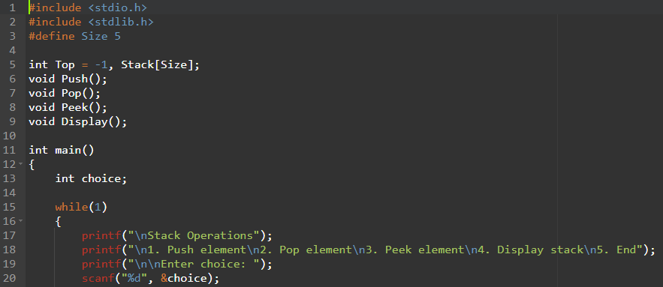

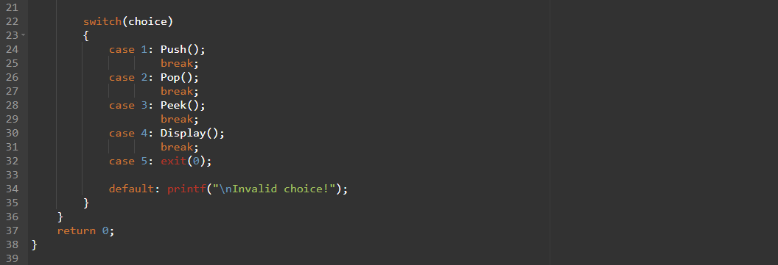
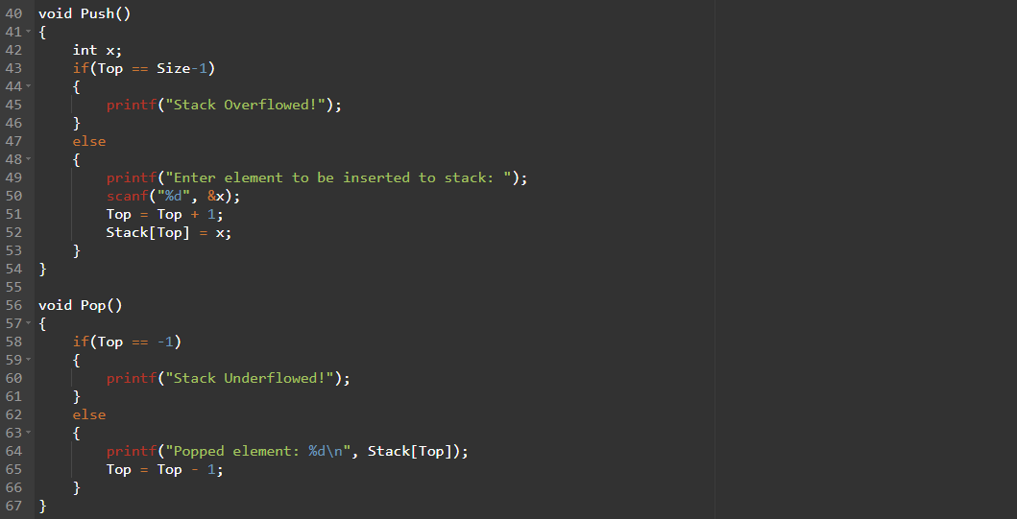
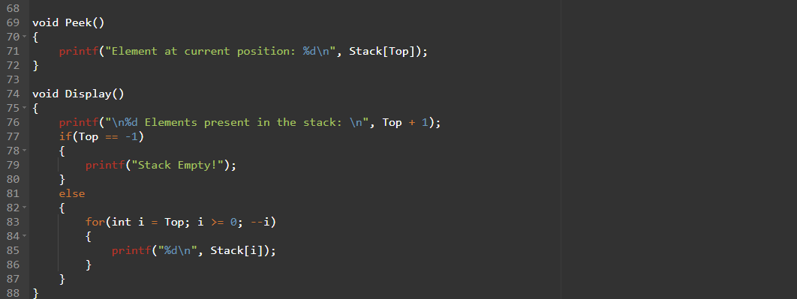

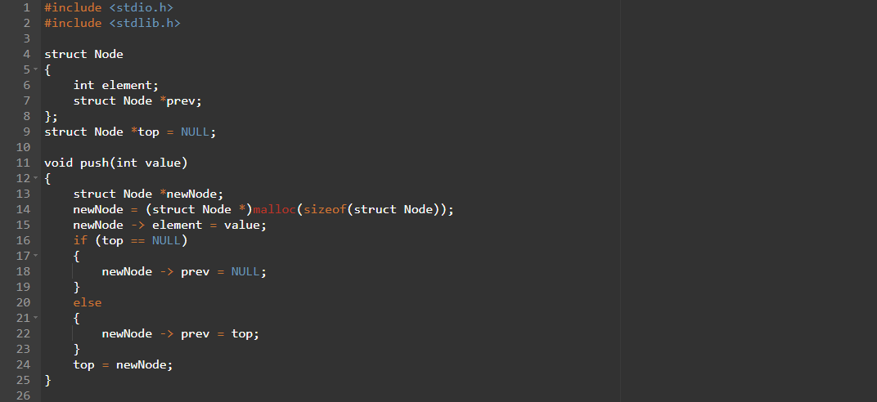
Stack implementation using Linked Lists:

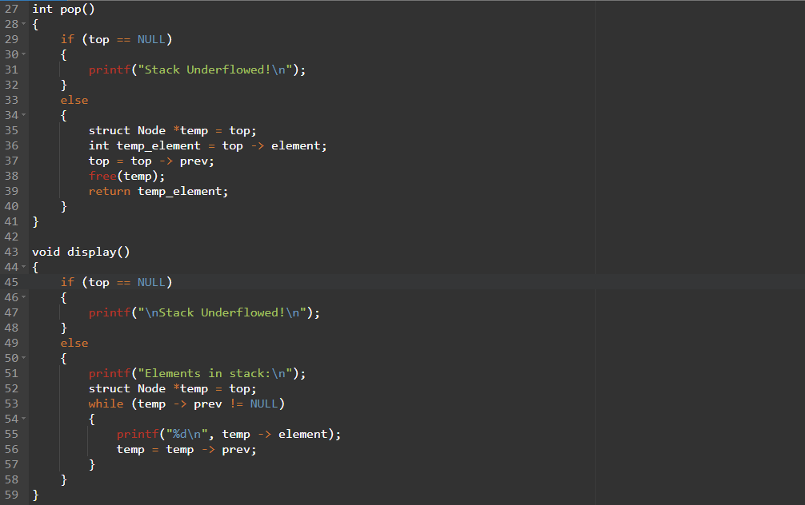

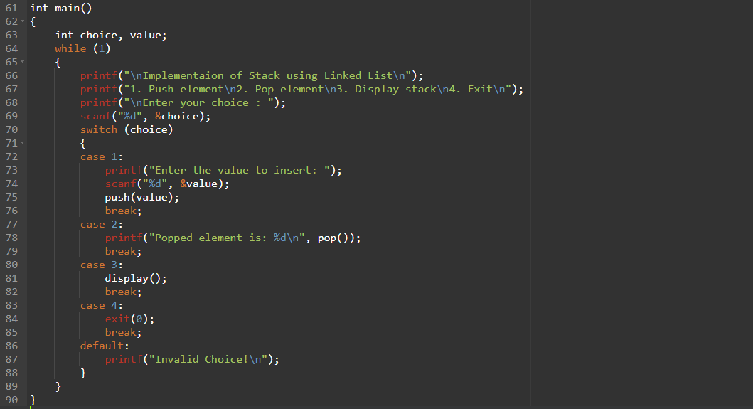

Output Screenshots:
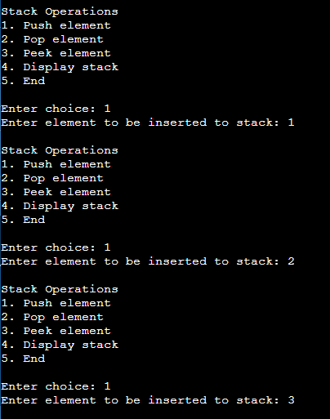

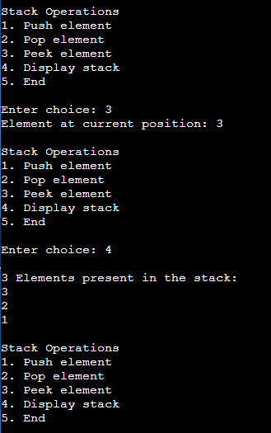

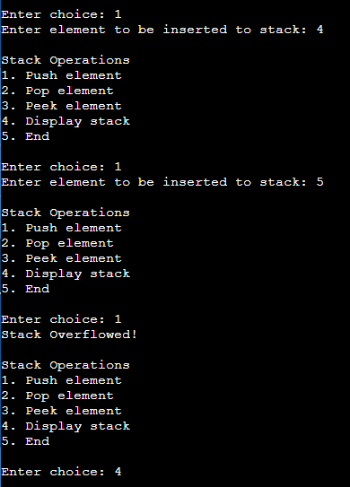

.

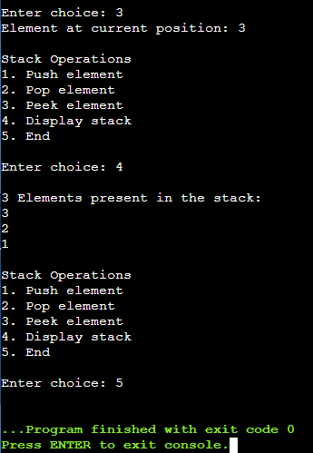



Applications of Stack:
- Converting infix to postfix expressions.
- Undo/Redo operation in word processors.
- Recursion
- Forward-backward surfing in browser.
- Backtracking
Explain the Importance of the approach followed by you.
- Learnt implementation of stacks with arrays and linked lists.
- Allocation of memory and memory management
- Understood various features of stacks and their applications in real life.
Conclusion:-
A stack is a data structure which is used to store data in a linear fashion.
Stack follows a Last In First Out (LIFO) principle i.e. the data which is inserted most recently in the stack will be deleted first from the stack.
There are many stack operations that can be performed on a stack. Some of them are push(), pop(), peek() and display().
Stacks have many real life applications such as undo/redo mechanisms, backtracking etc.
Post Lab Questions:
- Explain how Stacks can be used in Backtracking algorithms with example.
Backtracking is an algorithmic technique for solving problems recursively by trying to build a solution incrementally, one piece at a time, removing those solutions that fail to satisfy the constraints of the problem at any point in time.
Example:
N-Queens Problem – The goal is to place all the queens on the chessboard so that none of the queens are attacking each other.
- When we place the first queen in the first column of the first row, we record this placement by pushing a record onto the stack. This record contains both the row and column number of the newly placed queen.
- In addition to the stack, we also keep track of one other item: an integer which tells us how many rows currently have a queen placed.
- When we successfully place a queen in one row, we move to the next row. We always start by trying to place the queen in the first column of the new row.
- But each new placement must be checked for potential conflicts with the previous queen. If there is a conflict, then the newly placed queen is shifted rightward.
- Sometimes another conflict will occur, and the newly placed queen must continue shifting rightward.
- When the new queen reaches a spot with no conflicts, then the algorithm can move on. In order to move on, we add one to the value of filled and place a new queen in the first column of the next row.
- Each time we try a particular location for the new queen, we need to check whether the new location causes conflicts with our previous queens. If so, then we move the new queen to the next possible location.
- Sometimes we run out of possible locations for the new queens. This is where backtracking comes into play.
- To backtrack, we throw out the new queen altogether, popping the stack, reducing filled by 1, and returning to the previous row. At the previous row, we continue shifting the queen rightward.
- It is the use of the stack that lets us easily continue where we left off. The position of this previous queen is recorded in the stack, so we can just move the queen rightward one more position.

- Illustrate the concept of Call stack in Recursion.
Recursive functions use something called “the call stack.” When a program calls a function, that function goes on top of the call stack.
Eg: Factorial function using recursion
function fact(x) {
if (x == 1) {
return 1;
} else {
return x * fact(x-1);
}
}

